
Qwwdq

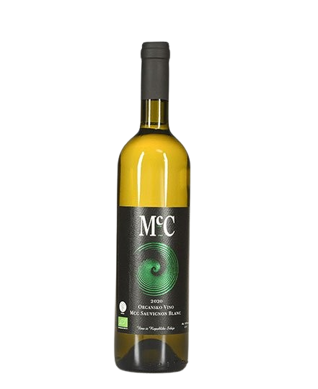
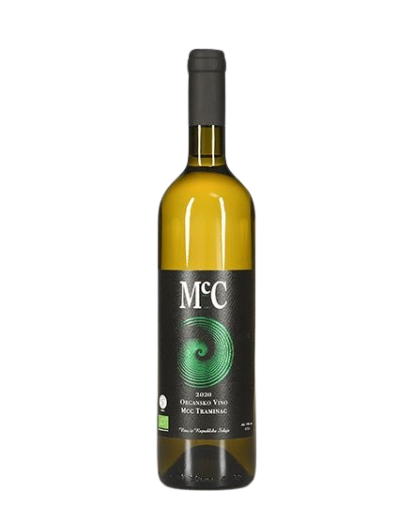
Sauvignon Blan
- Dry white wine- -

About the vine

Grape varieties:
- Sauvignon blan
Origin: Erdevik, Fruška Gora
Serving temperature:10-12 ºC

The wine has a greenish-yellow color and a fruity aroma, with a full and fresh structure, featuring fruit-forward notes and a subtle herbal finish on the palate.
Food pairings include dishes and salads based on white meat and white fish.
We produce around 1,000 bottles of Sauvignon Blanc per year.
This is the last variety we planted, and the wine has been on the market for only a few years. It is an exceptionally drinkable white wine with a pronounced varietal character.

